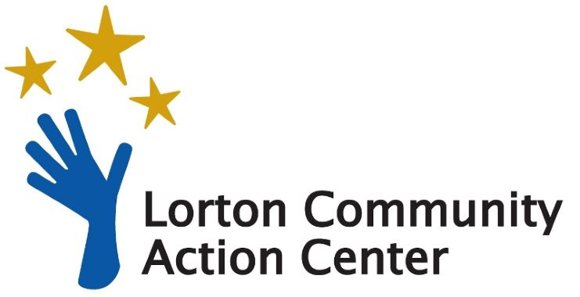
___________________________________________________________________
Stock Donation Form
Yes – I want to partner with Lorton Community Action Center to ensure a decent quality of life for southeastern Fairfax County residents by providing food, basic needs like emergency financial assistance to help combat rising rent and energy costs, and self-sufficiency programs. Here is my tax-deductible gift.

Please fill in the form below and send it to:
Lorton Community Action Center
P.O. Box 154, Lorton, VA 22199
Phone: 571-667-6323

Contact Information:
Name:
Address:
City/State/Zip:
Phone: Email:

Stock Transfer Information:
Total number of shares:
Company: Ticker Symbol:
Date of stock transfer:
To initiate the transfer, please contact your financial institution and provide the following:
1. Total number of shares, company, CUSIP or ticket symbol
2. Recipient: Lorton Community Action Center

3. Custodial Institution:
Raymond James
Broker Contact – Keith Barberis
Tax ID – 87-2361528
Contact phone – 240-800-3447
4. Delivery Instructions:
DTC 0725
FBO Lorton Community Action Center
Account number – will be provided

The gift is (please check one if applicable):
_In honor of: _In memory of:
_Please notify: Name: Address: City/State/Zip:

Privacy Policy: Lorton Community Action Center respects the privacy of our donors and we will not sell or trade a donor’s personal information to any other entity without the express permission of the donor.

